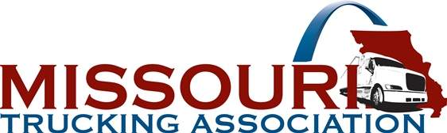

2020 MISSOURI TRUCK DRIVING CHAMPIONSHIPS
Deadline for Entries – May 1, 2020
53rd Annual Missouri Truck Driving Championships – Branson, MO - May 29th and 30, 2020

Missouri Truck Driving Championships Eligibility

Each Contestant:
- Must be accident free from May 30, 2019 to May 30, 2020.
- Must be a full-time truck driver. Spotters, hostlers, etc., are not eligible.
- Shall be continuously employed by the entering employer for at least 12 months prior to entry and not in layoff status at the time of entry or competition.
- Shall have driven and performed the duties of a professional truck driver for 11 of the 12 months prior to entry.
- Must hold a Missouri CDL or must operate out of a Missouri terminal.
- Must have appropriate class of CDL license & required endorsements. (Exception: Step Van Class)
- May only participate in one class of competition.
- Who is a consecutive two-time Champion in same class must sit out from that class for the following two years; exception: Step Van two-time Champions must sit out one year.
- Must not receive any form of pay, bonus, prize or other consideration for time spent in practice.
- Class winners must compete at the National TDC unless disqualified or detained due to medical emergency.
- Meet all eligibility rules on Driver Entry & Release Form, "Certification by Contestant"
- Will forfeit the right to compete or be disqualified for any misstatement made with respect to eligibility.

Companies entering drivers must be motor carrier members of MoTA. ATA membership is no longer required to participate in National Truck Driving Championships!
American Trucking Associations (ATA) National Truck Driving Championships (NTDC) rules are followed.

Contestants must be present for all official functions of the Championships, starting with the Driver Orientation and Written Examination early Friday morning. Roll will be called.

A company may, at its option, reimburse drivers for receipted expenses incurred in attending the Truck Driving Championships, but such expenses are limited to the participant and spouse.

**There is a $250.00 entry fee for each competing driver.

There is no limit on the number of entries per class for each company.
Straight Truck Class Five-Axle Tank Class Three-Axle Class Five-Axle Flatbed Class Four-Axle Class Twin Trailers Class
Five-Axle Van Class Sleeper Berth Class Step Van Class**

THE NINE CLASSES OF COMPETITION ARE AS FOLLOWS:

**Step Van Class – Open Class! The class is not limited to drivers who regularly drive step vans. However, competitors must adhere to all rules and eligibility requirements and take the same written examination. Scores from the step van class will not count toward Rookie of the Year, Team scores, or Grand Champion. (No limit of drivers per company!)
INTENT OF ENTRY IN THE 2020 MISSOURI TRUCK DRIVING CHAMPIONSHIPS
THIS FORM INDICATES INTEREST ONLY
Please read the back of this form for help in understanding who may participate.
Please return this form at your EARLIEST CONVENIENCE to:
Company Name:_______________________________________________________________ Street Address: ________________________________________________________________ City, State & Zip: ______________________________________________________________ Contact Person: _______________________________________________________________ Email Address: ________________________________________________________________ Phone: _____________________________Fax: _________________________________

Upon receipt of this completed form in the MoTA office, indicating your interest in the Championships, we will forward to your attention "Entry Forms" and "Facts for Drivers" books for each entry as well as 2 shoulder patches for each. All forms pertaining to the event, including the banquet and concessions, will be included.

PLEASE ESTIMATE NUMBER OF DRIVERS TO BE ENTERRED IN EACH CLASS:

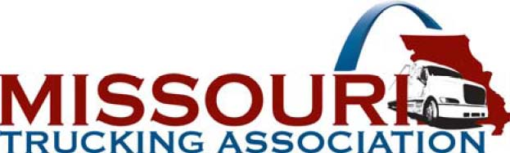
P O Box 1247 Jefferson City, MO 65102-1247
FAX: 573-634-4197
amanda@motrucking.org
This form is for planning the event;
PLEASE submit as soon as possible in advance of other forms.

______Straight Truck | ______Five-Axle Tank Class
______Three-Axle Class | ______Five-Axle Flatbed Class
______Four-Axle Class | ______Sleeper Berth Class
______Five-Axle Van Class | ______Step Van Class
______Twin Trailers Class | Total _______

